**Builder Design Pattern**

**Assignment - 2**

Name: Heet Dobariya Roll No. - 22BCP177 Group - G5

* **Program :** Create a Builder Design Pattern by taking any suitable example.
* **UML Diagram :**

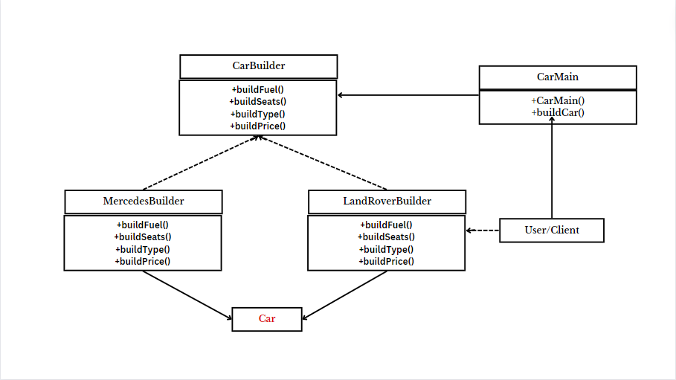

* **Code :**

package CarBuilder;

public class Car

{

private String fuel;

private int seats;

private String cartype;

private double price;

public void setFuel(String fuel1)

{

this.fuel = fuel1;

}

public void setSeats(int seats1)

{

this.seats = seats1;

}

public void setType(String type1)

{

this.cartype = type1;

}

public void setPrice(double price1)

{

this.price = price1;

}

public void showCar()

{

System.out.println("Car [Fueltype ="+fuel+", No. of seats ="+seats+", Car Type =" +cartype+", Price ="+price+"]");

}

}

package CarBuilder;

public interface CarBuilder

{

public void buildFuel();

public void buildSeats();

public void buildType();

public void buildPrice();

public Car getCar();

}

package CarBuilder;

public class LandRoverBuilder implements CarBuilder

{

private Car c;

public LandRoverBuilder()

{

this.c = new Car();

}

@ Override

public void buildFuel()

{

c.setFuel("Diesel");

}

@ Override

public void buildSeats()

{

c.setSeats(5);

}

@ Override

public void buildType()

{

c.setType("SUV");

}

@ Override

public void buildPrice()

{

c.setPrice(15000000);

}

public Car getCar()

{

Car newcar = this.c;

this.c = new Car();

return newcar;

}

}

package CarBuilder;

public class MercedesBuilder implements CarBuilder

{

private Car c;

public MercedesBuilder()

{

this.c = new Car();

}

@ Override

public void buildFuel()

{

c.setFuel("Petrol");

}

@ Override

public void buildSeats()

{

c.setSeats(5);

}

@ Override

public void buildType()

{

c.setType("SUV");

}

@ Override

public void buildPrice()

{

c.setPrice(30000000);

}

public Car getCar()

{

Car newcar = this.c;

this.c = new Car();

return newcar;

}

}

package CarBuilder;

public class CarMain

{

private CarBuilder cbuild;

public CarMain(CarBuilder cbuild)

{

this.cbuild = cbuild;

}

public void buildCar()

{

cbuild.buildFuel();

cbuild.buildSeats();

cbuild.buildType();

cbuild.buildPrice();

}

}

package CarBuilder;

public class CarShop

{

public static void main(String[] args)

{

CarBuilder cbuild;

CarMain cmain;

Car c;

cbuild = new MercedesBuilder();

cmain = new CarMain(cbuild);

cmain.buildCar();

c = cbuild.getCar();

c.showCar();

}

}

* **Output :**

